**P7.1 Solution**

**Pre-Reading Exercise**

1. In a circle, the two foci of ellipse merges into one and the semi-major axis becomes the radius of the circle.
2. Perihelion, Aphelion.
3. **Variable**;

The areal velocity is constant but velocity keeps changing.

1. **True**;

See Kepler’s second law.

**+**

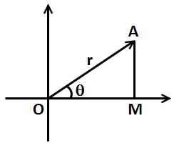



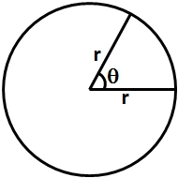

Corresponds to

Corresponds to

1. ;

Unit vector perpendicular to is given by

Gravitational force is from to

1. Force is negative

**Homework**

1. Given, ;

According to Newton’s law of gravitation,

1. Using Kepler’s Third Law of planetary motion

If becomes half ⇒ will change accordingly

⇒

⇒

Which means that earth will now complete its circle (year) in days

Note: when number of days are asked it indirectly means that we have to calculate its time period

1. Kepler’s Laws are valid for other celestial bodies also like earth and moon and also for artificial satellite.

Radius of geostationary satellite

Time period of geostationary satellite

Radius of spy satellite

Time period

Now

Note: A few hundred above the earth is very small compared to the earth’s radius

1. According to Newton’s laws of gravitation,
2. Here, we have to find the proportionality constant before the term

In a circular orbit, the centripetal force is provided by the gravitational acceleration between the planets.

Also, the time period is given by,

Replacing the value of from the first equation into second,

So, the proportionality constant is

1. Given, ; ;

From universal gravitational law,

Solving,

1. Let is the distance between earth and the sun and be the distance between the Jupiter and the sun.

From Kepler’s 3rd law,

1. From universal gravitation law,

Mass of sphere = Volume * Density,

Mass, ; where k is a constant

1. 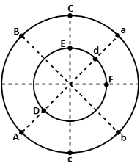Figure out by symmetry if there are any forces cancelling each other.

We have marked the masses with same letter, forces due to those are cancelling out

⇒ Net force will be the resultant of force due to and .

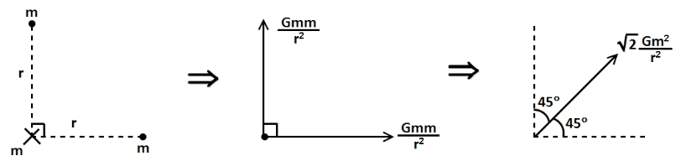

Magnitude

Direction is towards particle or making with and axis.

1. We have to place a third particle on the axis such that the net force on it due to and is zero.

**Remember that gravitational force is always attractive.**

Let’s analyze the three cases

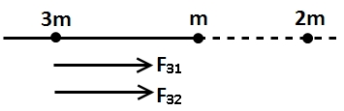i) To the left of the first two particles

Force on due to

Force on due to

Both and are towards right ⇒ resultant cannot be zero.

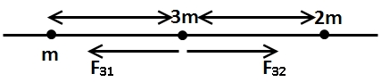ii) Between them

Resultant can be zero as directions are opposite

and

For ⇒

⇒ For resultant to be zero has to be less than i.e. particle has to be closer to {less massive particle}

b) You can observe that changing to will not change anything. The ratio of and depends on the masses and and hence, the result will remain unchanged.

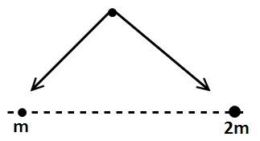c) Try placing the third particle off the axis and draw its FBD. You will find no point where the resultant is zero.

The two forces {due to and } has to be equal and opposite to cancel each other.

Note: In part a we can also argue that if we keep at the mid point of and then attractive force due to will be greater. To compensate that we have to shift towards to increase its attractive force {as for gravitation}

1. To cancel the force due to should be towards direction.

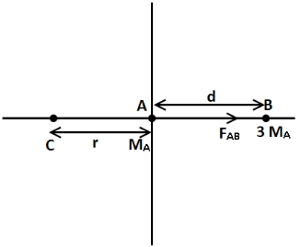⇒ Particles is on the left of

Let the distance be

⇒

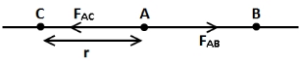⇒

⇒

⇒

⇒ coordinate is [ because it is on the left of origin]

1. 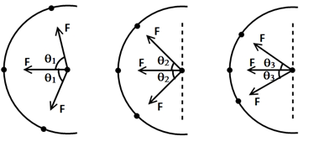We have to compare the magnitude of gravitational force on the particle at the center.

First observe that in and all other particles {except the center one} are at the same distance from central particle and have same mass

⇒ Magnitude of gravitational force exerted by each of them on central particle Then what is the difference in and ?

Direction of these individual forces are different hence the net force is different.

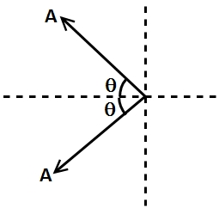You can argue that is greatest in configuration using vector algebra

The net resultant will be component will be cancelled out}

As decrease, increases

⇒

So,

1. Given than

Pull due to earth Pull due to sun

⇒

⇒

⇒

⇒

The probe should be placed from the earth.

1. We are given that orbital radius and Time period of one celestial body and we have to find time period of another celestial body (around the same planet) given its radius.

Kepler’s Third Law

⇒

Earth days

Earth days

1. Kepler Law,

⇒ days

days

1. 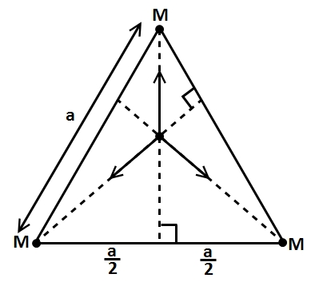Distance of centre particle from all three particles

Forces on due to three particles are

We can also say that by symmetry has to be equal to but if we go by vector addition then the three force vectors should cancel each other

⇒

The relation does not depend on the value of

1. 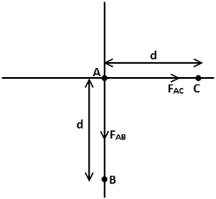 Force on a due to

[direction as shown]

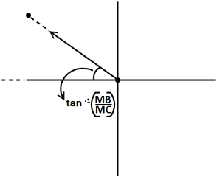as we have to find for which force on is zero.

⇒

at an angel with axis.

(Assuming that r = d)

should be in second quadrant and near axis.

1. 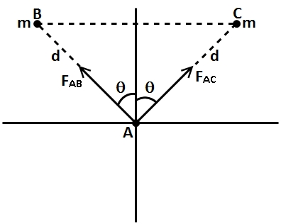 [Magnitude depends only on distance and masses]

Observe from the diagram that the components of and will cancel out each other.

But there components will get added

⇒ will be in the direction

Or because both vectors are equal in magnitude then resultant will be in the middle i.e. axis

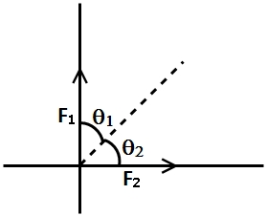b) Now we know that in addition of two vectors resultant leans more towards the vector with greater magnitude.

If

Now if we increase the distance between and

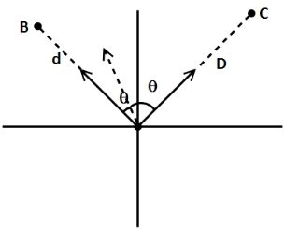⇒ decrease

It means as distance between and increases becomes smaller than

So the resultant will shift towards line and when becomes zero i.e.

Then

Limit of change is anticlockwise

1. 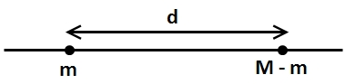 is fixed

⇒ Gravitational force between two particles

We have to maximize this force

Now are fixed quantities

For to be maximum has to be maximum

In other words

Why differentiate w.r.t ? Because it is the only quantity which can change (variable)

⇒

Note: Remember using differentiation while calculating maximum and minimum, always differentiate w.r.t to a varying quantity.

1. 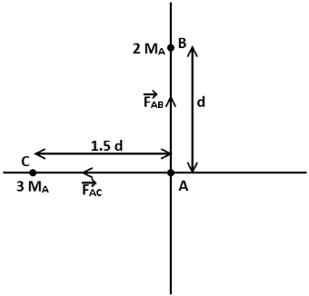

Pull is towards and

⇒

Convert RHS into form so that you can find and by comparing.

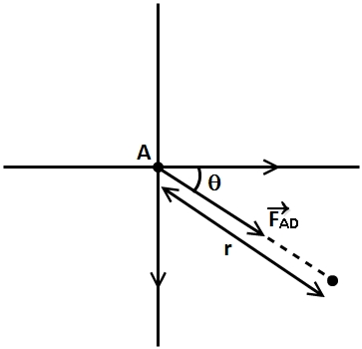⇒

⇒

⇒

coordinate

coordinate

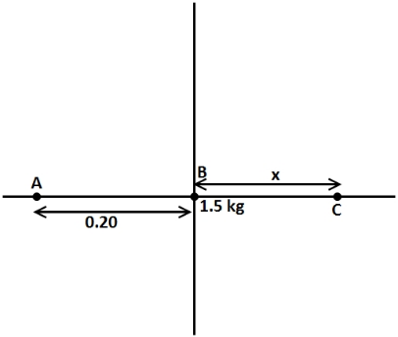

1. on

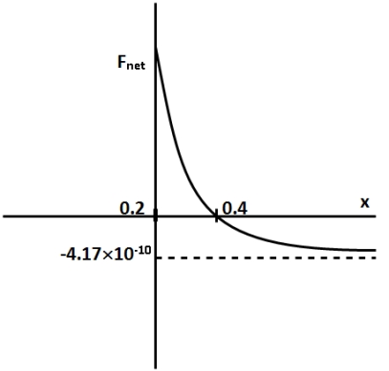We calculate this expression so that we can put some values of in this and check corresponding values from graph.

The two points of interest in the graph are where

and where

i) and

⇒

⇒

ii) and

⇒

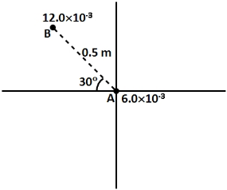⇒

and

1. at an angle from

on

⇒

⇒

Putting and

We get, and

1. 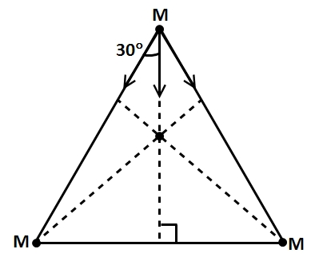At any instant the configuration of the system is as shown.

The system will rotate about its center of mass that you can see by symmetry

Distance of each particle form C.O.M [Centroid]

Also, Force of gravitation on a particle due to other two must be towards the centroid

Net force on one particle

This force (net) is responsible for that particle’s movement in circle.

i.e. this force will provide centripetal acceleration.

where

⇒

⇒

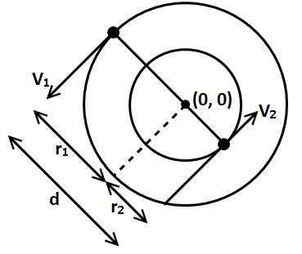Time period

1. Calculating position of center of mass using its formulas

⇒

Using concept of circular motion

Particle

Centripetal acceleration is provided by the force of gravitation between them

⇒

Because same relation applies on second particle

Calculate and in terms of

⇒ and ;

Particle 1

Particle 2

**P7.2 Solution**

**Pre-Reading Exercise**

1. Gravitational field
2. **Vector**
3. is mass of earth, R is radius of earth.
4. **False**; : Here mass is of the object producing gravitational field and not the test mass.
5. Inside hollow sphere, effective mass is zero.

At the center of ring, net effect cancels out.

**D**, At the mid-point, from symmetry, net effect is zero.

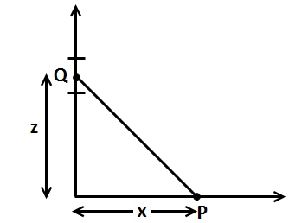

**Homework**

1. at P towards the mass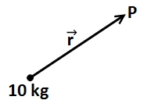

At P radially inwards

In vector form:

Direction of

At P

In other from [remember ]

1. Let that point be at x m from 10000 kg

Why left

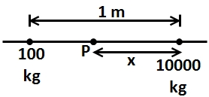Because we know that for gravitational field intensity to be zero at that point the gravitational field intensities due to both masses has to be equal in magnitude and opposite in direction. This is possible only in the region between the two masses. The gravitational field on the left of left mass and on the right of right mass will add and hence never be zero.

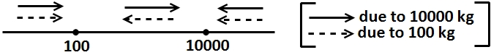

Now gravitational field intensity at P

1. Gravitational field intensity

Mass of particle

Displacement

Now as particle is moved slowly

[Work energy theorem]

[ Work done by ext. force

Work done by field]

Now we can calculate

. [ is the force ]

So work done by external agent

1. Calculate the net gravitational field intensity at vertex which is the vector sum of gravitational field due to all five particles.

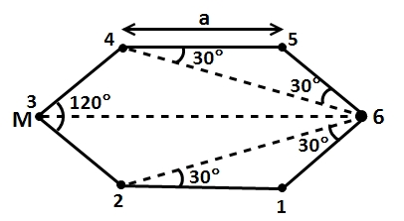

You need distance of vertex from other particles. Use trigonometry in the above diagram to find relevant distances {as shown}

Note: try to use symmetry when vectors are involved

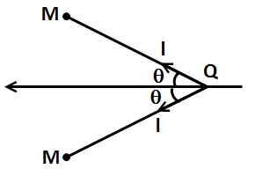You can see that resultant of (gravitational field) these two particles will be along the angle bisector and its magnitude will be

In this question this will apply for masses 2 and 4; 1 and 5 resultant of both pass will be towards particle 3

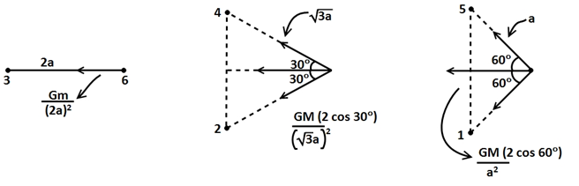

Resultant gravitational field intensity

Force experienced by mass

] ; Towards the particles just opposite to it

1. Calculate it by dividing the x axes into three parts: i)left, ii)middle, iii)right of two particles

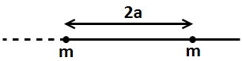

1. Left

is just the distance and not the coordinate

Gravitational field intensity at (rightward, positive)

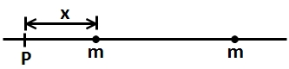You can see that as we go leftwards (towards) the above value tends to Zero decreasing continuously.

And as the expression (field intensity tends to )

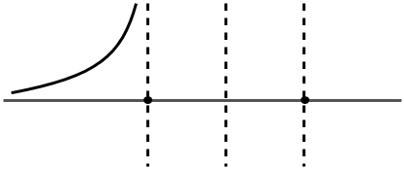

1. We will deal with right part before coming to middle. Its calculation is exactly as for left region but the sign (direction) is - (leftwards)

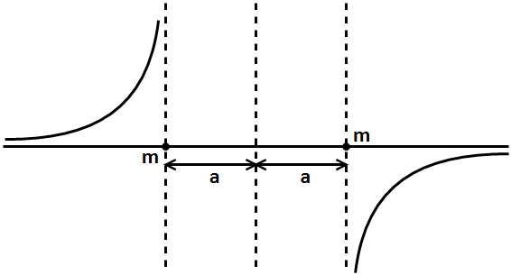

1. Middle

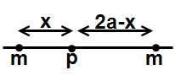Gravitational field intensity at P

As

As

Also you can see that before is a quanity because for and for P is

Note: at {as expected}

1. For a sphere, if we want to calculate gravitational field intensity at any point outside it, the sphere behaves as such that the whole mass is concentrated at its center

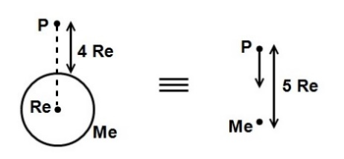

Gravitational field intensity at towards its center

Towards earth center

1. means axes. So we have to find gravitational field at every point of axes for a continuous mass. System we will take a small element of mass and calculated gravitational field due to

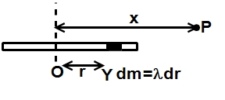 Where

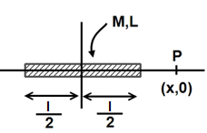Gravitational field at P due to r varies from to

;

=

(Integration is upon r and not x)

**Note**: for is not defined as it is defined at some distance from mass sign denotes towards the rod; and for it will be leftwards and for it will rightwards

1. Gravitational field intensity due to black hole at a distance from its center will be where where mass of the black hole

Now gravitational field intensity at the nose of ship

Gravitational field intensity at the rear

Total force on the space craft where

(Assume uniform distribution)

Where sign represents towards black hole



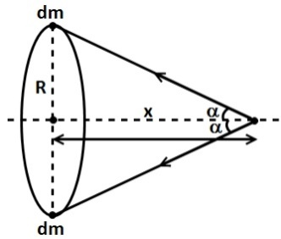Net gravitational field due to two diametrically opposite elements

{ sign means towards center}

As all pair of points on the ring are symmetric wrt.

Net gravitational field of ring

To maximize this we have to find max value of

⇒

Force needed to keep a particle at rest

away from center

1. 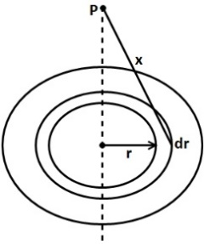You can treat a disc as a combination of many rings of different radius and infinitesimally small thickness.

You already know the electric field intensity of a uniform ring at a point on its axes.

Gravitational field intensity at P due to a ring of radius

is the mass of the ring

is the mass density of the disc and area of the ring (surface) is [length x thickness]

[Integrate by substituting]; towards the center.

1. Find the gravitational field intensity due to semicircular ring at its center take two symmetrical mass elements at an angle from the line as shown

Length of elements)

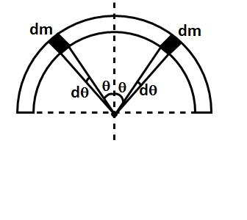

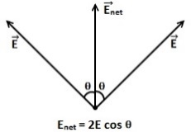The net gravitational field due to these two elements will be along the line (angle bisector)

[ Because we are covering both sides simultaneously]

So gravitational force on

Implies towards the ring}

1. Remember two things for a spherical shell (uniform)
2. Inside it the gravitational field is Zero at every point due to it
3. 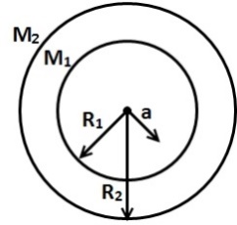Outside it gravitational field is just same as of a particle at its center
4. where a<R,

Point is inside both shells

Gravitational field =0



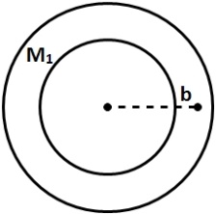i.e. point is inside the shell with mass but outside the shell with mass

Gravitational field due to outer shell

And Gravitational field due to



i.e. point is outside both shells

Gravitational field=

1. Join the two parts you will get a complete spherical shell where A coincides with B

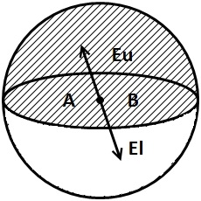We know that inside a uniform spherical shell gravitational field is zero

Net gravitational field at A due to B is zero

The gravitational field at due to lower (bigger) section has to be cancelled out by the remaining part of the shell upper section

Gravitational field at B due to lower section has to be equal and opposite to that of upper section at A

If we separate both sections their gravitational field at same section does not change in magnitude

1. Whenever you deal with a solid sphere, imagine it as a combination of many (infinite)

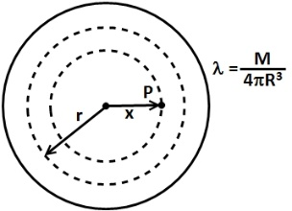Spherical shells with different radius and negligible thickness

Consider shells having radius ()

All these spherical shells have point P inside them at point (P) gravitational field due to these shells will be zero but the gravitational field due to shells having radius will be same as if a particle of mass [of all shells ] is kept at the center

Note: you already have done this exercise for two or three shells this is exactly same but now the number of shells is not finite.

So mass of all shells withmass of solid sphere with radius x

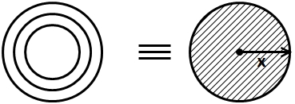

Gravitational field due to this mass

Similarly gravitational shells field

Note: at the boundary of the sphere the whole sphere will be responsible for the gravitational field i.e. same as if M is kept at the center

1. 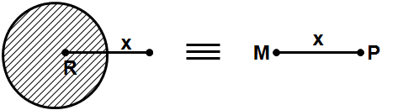

The point is outside of every spherical shell

Gravitational field

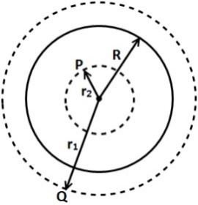

1. Gravitational field at Q

(Outside the sphere)

Gravitational field at

(Inside the sphere)

1. While dealing with gravitational field of spheres (shells and solids) always observe whether the point (where is being calculated) is inside it or outside it

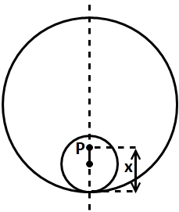a)

Point it inside both spheres

Gravitational field due to shell will be zero and due to solid sphere will be

(As it in inside both)

Why Distance from the center of sphere

Gravitational force on

Sign implies towards the center of sphere}

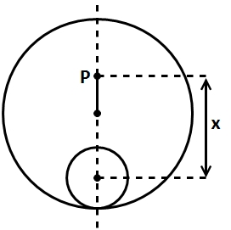

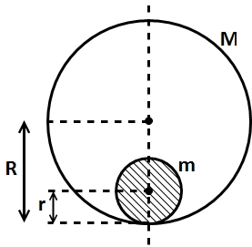Point is outside the solid sphere the solid sphere but inside the shell

There will be no gravitational field at P due to shell

Net field=field due to solid sphere=

x>2R

Point is outside both of the sphere and the shell

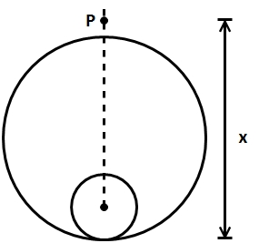 Net field at P

Due to shell due to sphere

Force at P

1. Again a continuous mass distribution. We need to break into small elements. We will choose discs as our element a disc of radius rat height h from the base and thickness (some)

To calculate the mass of this elements we need its thickness which is not dh as its thickness will be the sland distance

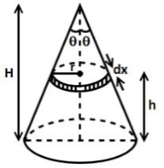Thickness

Volume of elements

Mass of element

Gravitational field at vertex due to this element

Net field at vertex= .

1. 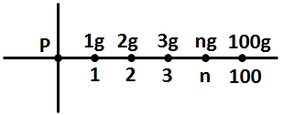Field at origin, due to a particle at

Field at origin due to be particle at

In general field at origin due to particle

At is origin

So net field at origin

1. 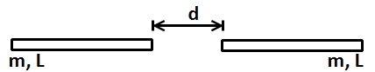We have two continuous mass distribution we will first calculate the gravitational field due to one rod at a variable r from its end

We have already calculated it in Q7

C:\Users\givepeaceachance28\Downloads\P7.2's material\P7.2's material\16th sept\1a.jpgNow we will calculated the force due to first sod on a small mass on of another rod

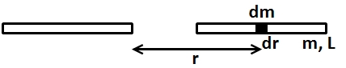

Total force

## P7.3 Solution

**Pre Reading**

1. Gravitational potential

1. **True**;

Gravitational as potential is a relative concept. It depends on the point of reference taken as zero. *Change in gravitational potential is absolute.*

1. **Negative**;

Gravitational potential is taken to be zero at infinity, hence a negative potential in planetary system signifies that system is bound to each other.

1. **True**;

Gravitational field is conservative field and work done by external force in it is equal to change in gravitational potential energy.

1. **B**;

Potential is defined for conservative force only.

1. **B**;

The negative value of gravitational potential increase with decrease in distance. Hence, the net value decreases with decreasing distance.

**Homework**

1. Let mass of the earth be and mass of Mars be

Given: = 0.11

= km

= =km

Volume of Earth

Volume of Mars

0.21

B) Gravitational acceleration on Mars

We do not have the value of but we know the value of gravitational acceleration on Earth

We can use this as is given to us

Now Gravitational acceleration on Mars

=2.06

1. A) N

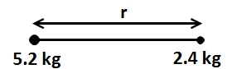

Now we have to calculate the potential energy of the system

Gravitational potential energy

We need r (separation between two particles).

We will use (gravitational force) for this

m

So Gravitational potential energy

=0.053 J

Now you triple the separation between them

Gravitational potential energy ; where ‘r’ is the initial separation

Change in gravitational P.E

i.e. two-third of the Initial P.E.

Work done by you 0.035

Work done by gravitational forces

**Note:** Work done by a conservative force (in this case gravitational) is equal to negative of change in potential energy due to it.

And Work done by other forces

1. We will calculate the gravitational potential energy in both situations and then the change in potential energy. As there is no change in K.E (at rest both initially and finally) we can relate work done on the system to

**Initial P.E**:

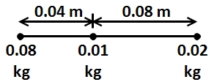

**Final P.E.**

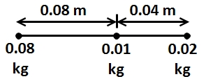

=

Work done by you

Work done by gravitational forces

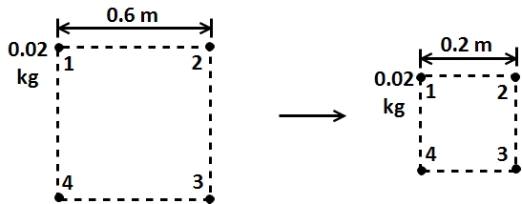

Take each pair of particles and write P.E of them. Total P.E of the system will be the addition of P.E of these pairs

Initial Gravitational P.E

**Note:** There should be terms i.e 6 terms as you can pick (choose) two particles from four in ways

Note: 4 terms represent 4 sides and rest two represent two diagonals

Similarly

1. As there is no other force acting on the particle other than the gravitational force due to the ring. We can easily use the work energy theorem to calculate the desired speed all points on the ring are equidistant from mass m

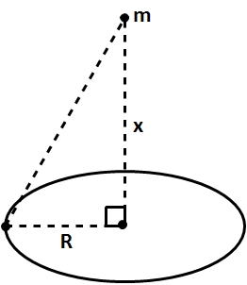

Potential energy of m and mass d of the ring when it is at distant on the axes

As it is a scalar quantity the P.E due to every dM’ element will simply add

(When it is at center)

Now,

(Work-energy theorem. No other force is acting)

So

1. Treat a disc as a combination of infinite rings of varying radius and negligible thickness.

We have already calculated the potential due to a uniform ring of radius R and mass M at a point on its axes in the previous question.

**Note:** We calculated potential energy but if we divide it by mass of the particle (other than the ring) we will have potential

Potential due to a uniform ring at a point on its axes (z units from center)

**Note:** M is the mass of the ring

Take a ring with radius and thickness dr

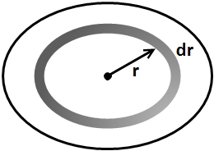

Mass of this ring

Potential due to the ring



We know that potential and field intensity are related as

where is the reference point

[in this case reference point is

so, [why dx ? because only has component in

1. and we have to find

Now [where is partial differentiation.]

[Others are zero because doesn’t depend on and ]

1. Now the disk is non uniform also varies with

We will again take uniform rings of radius r and thickness and use integration.

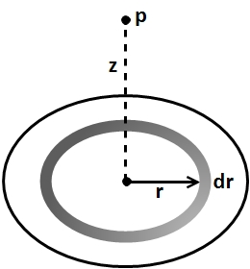

Potential at p due to this ring

Solve both integrations separately. [Use ]

1. As we already know the gravitational field due to a spherical shell at every point [inside or outside].

We can use this relation between and V to find potential at any point.

**Alternatively**: you can say that outside its boundary a spherical shell behaves like a particle kept at its center.

b) There is no gravitational field inside the shell there will be no change in potential from the boundary of the shell when we come inside.

When

**Note:** if

1. We are dealing with conservative forces and energies only. We will use work energy theorem in this question.
2. Probe is launched from the surface of the planet Alpha i.e. at a distance of from the center

So initial potential energy of system J

Initial K.E

Total mechanical energy has to be conserved as there are no forces which are doing work here

**Note:** You have already considered gravitation potential energy thus making the gravitational force internal

; second part is the P.E at final position

B) Maximum distance means that the space probe can go no further i.e speed at the point =0

Conserve mechanical energy

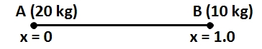

A) Gravitational P.E =

U

B) Now when B has moved the potential energy of the system changed but mechanical energy remains conserved i.e. some potential energy is converted to kinetic energy.

U=

; [Initially at rest]

1. We need the mass of the asteroid so that we can find its field and other quantities.

Gravitational acceleration at its surface

; [Gravitational acceleration has magnitude equal to field at that point.]

Now

1. It will go till its K.E becomes Zero. Again mechanical energy of the system is conserved

It will go 7500 km from the center

It will go 7000 km from the surface of asteroid.

1. Again it has some potential energy (but no at the initial point [from center]

After reaching the surface, it will have some kinetic energy and some but the sum has to be constant. [

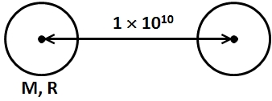

They are initially at rest

But they will start coming closer due to gravitational attraction. In this process some potential energy will get converted into K.E but total energy will remain conserved

**Note:** you can argue that their speeds will be some due to momentum conservation

So

1. 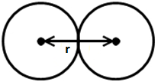 When they are about to collide

Note: is distance between the centers

So

⇒

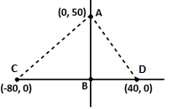

Gravitational potential due a uniform sphere at a distance r outside the sphere

**Note**: Potential is a scalar quantity. It can be added simply

Potential at origin due to other spheres

J

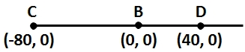

Gravitational P.E

Joules

B) Now if you put A back, some negative quantity will be added of four particle is less than that of system is part a

C) When you are removing A, you are increasing the P.E of the system without changing the

Work done by you is

D) when you replace A, you are decreasing the without changing the

**Note**: you can also comment on the sign of your work done by observing in which direction {again the motion/towards} to move it slowly {without changing it }.

While removing A, the other particles are typing to attract it towards them so you have to apply a force in opposite direction (in direction of motion)

2. at particle place at origin

Magnitude

1. Now is given to be zero

or As we are moving along direction, only the component of which is along this direction will be responsible for change in potential

Similarly for , we are moving along direction

c) You can either calculate {change in potential} directly from or can choose convenient paths

**Note:** Potential change between two points does not depend on the path taken.

Calculate from and then

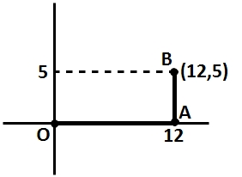

**Why these paths?** Because at one time we are moving along one direction only. So we only have to deal with the component of in that direction as we did is previous part

Total

⇒ is relates to by;

D) Now we are taking the particle from

This two points are equipotential as we have already calculated [both have

There is no change in potential when the particle is transferred

⇒ No change in

**Note:** Net work done to transfer from is zero.

1. Considering the motion between point &

Earth gravity is a conservative force, so mechanical energy is conserved

.

KE at

.

1. when the potential energy is safely due to the .

Potential energy of

kg.

So,

At ,i.e when A is away from midpoint of and on .

.

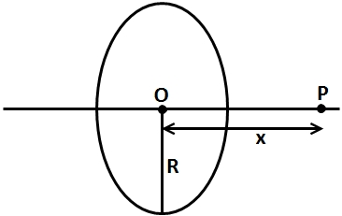

.

1. Since is at same distance from all the particles of the ring and also

Potential is a scalar quantity.

,

**P7.4 Earth and Gravity**

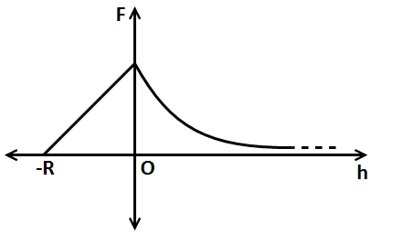**Pre-Reading Solution**

1. A)  **to infinity**;

Force is from centre to infinity.

B) For to

For.

Also, use the transformation of graph theory to plot the curve.

The latitude of is.

P lies in the north hemisphere

Co-latitude

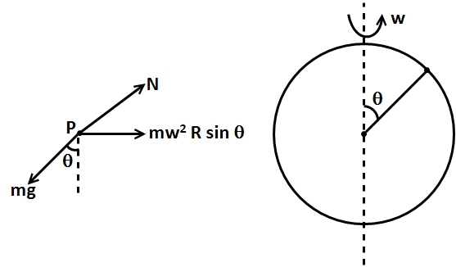

1. **C**; Conservation of energy
2. .

Energy on earth

Energy at infinity

.

1. .

**Homework Solution**

Q1. Escape velocity from surface of earth.

The velocity of practice is less than 11.2 km/s, it will reach a certain height before falling back.

Conserving energy between surface and that height (H)

⇒

⇒

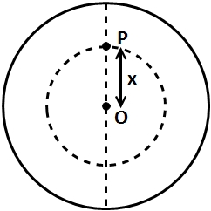Q2. Assuming the density of the earth to be same,

Mass of inner sphere,

3. Escape speed means speed at which particle free itself from gravitation field of planet.

Given,

Speed of particle, .

Energy equivalent of 11.2 km/s is consumed in overcoming earth field. Let v be velocity at infinite distance.

So,

Q4. Since earth’s gravity is a conservative field air resistance is absent, we can conserve mechanical energy.

(at earth’s surface) (at height R)

This is the velocity that should be imparted to the body.

Q5. Since, mass of the body is constant, the weight changes due to “g”.

We have to calculate height at which g is reduced to half.

Q6. Since, earth rotates on its axis, every point on the earth’s surface rotates in a circle and hence experience an acceleration.

Due to this the spring force is not equal to weight.

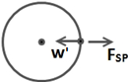given, .

or

Now earth completes 1 rotation in 24 hours

Point on the surface travels 2 Distance in 24 hours sec.

.

It will weigh 0.9965 kg.

Q7. Height of Mt. Everest .

Therefore approximation can be taken.

.

Q8. Since, depth of mine

Approximate formulae can be used.

.

Q9. Given,

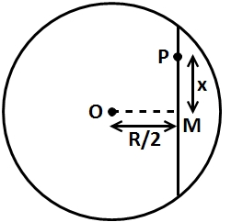

Mass of earth in radius . (Assuming uniform density)

Force on particle at

Now, the force is along PO, and since the tunnel is open and frictionless, the forces perpendicular to tunnel will be in equilibrium

.

**Note**: The force due to wall is constant. Only the component along tunnel will vary.

Q10. Weight of man at certain latitude is given by

For earth,

A)

B)

Q11. At equator weight is reduced due to rotation. While at South Pole, it will be reduced due to height.

Decrease at equator = Decrease at pole

Putting = rad/s.

and

Q12. Apparent weight at equator is given by

For

Time taken to complete 1 rotation

Q13. For moon;

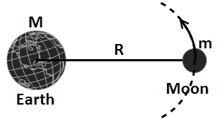

Time period of revolution,

.

Also,

Force of attraction between earth and moon provides the centripetal force.

Putting the given values,

.

Q14. Since earth’s gravity is conservative field, hence work done by external forcechange in potential energy.

Work done,

Putting values given in question,

(Mega joule)

Q15. Since the satellite is revolving at an orbit of radius R, Centripetal force should be provided by the earth’s gravitational force.

1. Velocity ;

.

1. Kinetic energy

1. Potential energy ( kinetic energy)

d) Time period

.

Q16. Angular speed, of satellite {

.

Let be the radius of satellite be R.

(Gravity centripetal force)

.

B) Time one fourth of a day 6 hour.

Q17. Conserving mechanical energy,

at surface .

.

Q18. Since energy is lost due to atmosphere, only 80% of total is available.

So, initial energy ; m=mass of rocket

Final energy is only potential energy of rocket mars system. (Since rocket will be at rest)

=.

Q19. Escape velocity of a planet is given by,

Where,=mass of planet

Radius of planet

.

;

.

20.

A) Acceleration due to gravity is given by.

(1)

When earth shrinks, its mass remains same and radius decreases.

Given, (

Differentiating w.r.t. R.

(2)

Dividing by

.

Change in g change in R).

**Note:** g varies with hence the % change in R is multiplied by to get % change in g. This is applicable for small change up to

Q21. Escape velocity

.

**Note:** For a escape velocity of light, earth has to compressed into a sphere of 9mm radius

This is the case with black holes where large mass is compressed into small volume so that even light cannot escape.

Q22. Escape speed from earth is given by ,

a). Given

Conserving energy between surface and highest point,

⇒

⇒

.

Required to escape

Given.

Conserving energy between surface and highest point.

1. for a particle to escape,

Least mechanical energy

.

Q23.

a) When an apple is dropped into the tunnel, the force acting on its towards the center. Due to which the apple will accelerate towards the other end of the tunnel.

The motion of the apple will be accelerated, but the acceleration will decrease (g decreases with depth) and will become Zero at counter. Here, at center particle will experience no force but it will have some velocity due to which it will continue to move towards the other end of tunnel.

Conserving energy between (1)

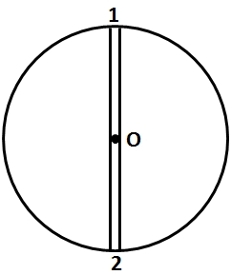Conserving energy between

The apple will reach the other end of the tunnel with Zero velocity.

Again it will be attracted towards the center. And this motion will be repeated. The particle will perform to and fro motion about center into the tunnel.

b) Let the height away from surface be H.

Given, ……(1)

……..(2)

Dividing

.

.

1. Let the depth be D.

……..(3)

Dividing

**P 7.5 Solution**

**Pre-Reading Solution**

1. **Accelerated**; satellite moves in a circular path and motion in a circle is accelerated.
2. **True**; Gravitational force provides the centripetal force for satellite.
3. **False**;

For velocity of orbiting satellite.

Total energy

1. 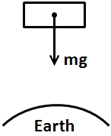**True**; see 3 for explanation
2. **False**; see 3 for explanation
3. **Geostationary**
4. The centripetal force is not a force but the effect of gravitational force.

(See figure)

1. Weight
2. See figure
3. 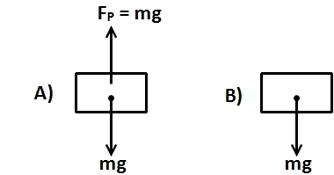

**Homework**

1. We will calculate the energy required to left a satellite of mass to a height above the surface. And also required to be in orbit of height

Energy required to left surface

required to be in orbit

Where [Centripetal acceleration due to gravitational force at that point]

⇒

Energy required to left required to be in orbit

[Half the radius of earth above the surface]

When : > 1

Energy required to lift will be greater for further heights

1. Mass of asteroid mass of earth

Radius of orbit of asteroid , radius of earth’s orbit

Now time period of asteroid revolution [Kepler’s law]

Now is time period of earth’s revolution i.e 1 year

Time period of revolution years

Now [ Mass of sun; equation true for both earth and asteroid]

So, Ratio of

1. Potential energy of a satellite at height h

Where, is mass of satellite and M and R is the mass and Radius of earth respectively.

In order for the satellite to orbit the earth at height h, the total energy required is given by

So, the extra energy must be imparted to the satellite in the form of kinetic energy.

imparted =

Time Period

1. The key point there is that angular momentum is conserved:

Which leads to , but . Therefore,

rad/s.

1. a) Because it is moving in a circular orbit, must equal the centripetal acceleration

Now ; where

= m.

b)

so

c) Gravitational acceleration

1. At any point constant

⇒

Take 2 point where is

to as shown

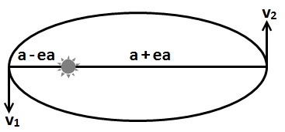

Now

[Conservation of angular momentum]

⇒

Also

From and

Now

⇒

⇒

1. (a) The pellets will have the same speed but opposite direction of motion, so the *relative speed* between the pellets and satellite is . Replacing with in equation of Kinetic energy is same as multiplying it by 4. Thus,

.

(b) We set up the ratio of kinetic energies:

.

1. (a) The force acting on the satellite has magnitude , where is the mass of Earth, is the mass of the satellite, and is the radius of the orbit. The force points towards the center of the orbit. Since the acceleration of the satellite is , where is its speed, Newton’s second law yields and the speed is given by . The radius of the orbit is the sum of Earth’s radius and the altitude of the satellite:

m.

Thus,

m/s.

(b) The period is

min.

(c) If is the initial energy then the energy after orbits is , where For a circular orbit the energy and orbit radius are related by , so the radius after orbits is given by .

J,

The energy after 1500 orbits is

and the orbit radius after 1500 orbits is

The altitude is

.

Here is the radius of Earth. The torque is internal to the satelliteEarth system, so the angular momentum of that system is conserved.

(d) The speed is

(e) The period is

min.

(f) Let be the magnitude of the average force and be the distance traveled by the satellite. Then, the work done by the force is . This is the change in energy: . Thus, . We evaluate this expression for the first orbit. For a complete orbit , and . Thus,

N.

(g) The resistive force exerts a torque on the satellite, so its angular momentum is not conserved.

(h) The satelliteEarth system is essentially isolated, so its momentum is very nearly conserved.

1. The magnitude of the net gravitational force on one of the smaller stars (of mass ) is

.

This supplies the centripetal force need3ed for the motion of the star:

,

where . Plugging in for speed , we arrive at an equation for period :

1. (a) Their initial potential energy is and they started from rest, so energy conservation leads to

.

(b) They have equal mass, and this is being viewed in the center-of-mass frame, so their speeds are identical and their kinetic energies are the same. Thus,

(c) With , we solve the above equation and find .

(d) Their relative speed is . This is the (instantaneous) rate at which the gap between them is closing.

(e) The premise of this part is that we assume we are not moving (that is, that body A acquired no kinetic energy in the process). Thus, , and the logic or part (a) leads to .

(f) And yields .

(g) The answer to part (f) is incorrect, due to having ignored the accelerated motion of “our” frame (that of body ). Our computations were therefore carried out in a non-inertial frame of reference, for which the energy equations are not directly applicable.

1. (a) From Eq. 13-40, we see that the energy of each satellite is . The total energy of the two satellites is twice that result:

.

(b) We note that the speed of the wreckage will be zero (immediately after the collision), so it has no kinetic energy at that moment. Replacing with in the potential energy expression, we therefore find the total energy of the wreckage at that instant is

(c) An object with zero speed at that distance from Earth will simply fall toward the Earth, its trajectory being toward the centre of the planet.

1. We first use the law of periods: , where is the mass of the planet and is the radius of the orbit. After the orbit of the shuttle turns elliptical by firing the thrusts to reduce its speed, the semi-major axis is , where is the mechanical energy of the shuttle, and its new period becomes .
   * 1. Using Kepler’s law of periods, we find the period to be

(b) The speed is constant (before the fires the thrusters), so

.

(c) A two percent reduction in the previous value gives

.

(d) The kinetic energy is .

(e) Immediately after the firing, the potential energy is the same as it was before firing the thruster:

.

(f) Adding these two results gives the total mechanical energy:

.

(g)We find the semi-major axis to be

(h) Using Kepler’s law of periods for elliptical orbits (using instead of ) we find the new period to be

This is smaller than our result for part (a) by

Comparing the results in (a) and (h), we see that elliptical orbit has a smaller period.

Note: The orbits of the shuttle before and after firing the thruster are shown below. Point corresponds to the location where the thruster was fired.

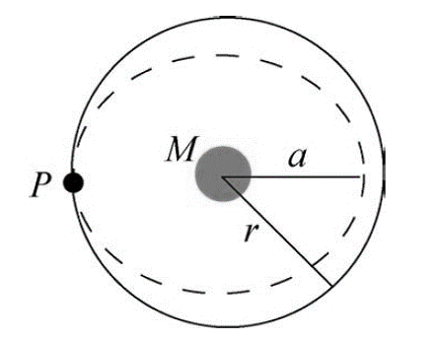

1. (a) From previous chapters, we have , whre may be interpreted as an average acceleration in cases where the acceleration is not uniform. With , , and , we find . Therefore,

.

(b) The acceleration is certainly deadly enough to kill the passengers.

(c) Again using , we find

.

(d) Energy conservation gives the craft’s speed (in the absence of friction and other dissipative effects) at altitude after being launched from (the surface of Earth) with speed . That altitude corresponds to a distance from Earth’s center of

.

With (the mass of Earth) we find . However, to orbit at that radius velocity required is given by

The difference between these two speeds is which presumably is accounted for by the action of the rocket engine.

**Miscellaneous Objectives**

**HINTS AND SOLUTION**







With decrease in the value of R, Potential V at center will decrease.



Relative velocity

1. 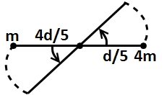Value of will be same for both.



1. On earth’s surface potential energy of particle is

And kinetic energy at a velocity equal to its escape velocity is

i.e.

Or total mechanical energy is zero.

1. Potential energy at a height of from surface of earth

And total energy of a satellite at a height

Given that

1. v depends only on r
2. Kinetic energy at center Potential energy at surface Potential energy at center

Or

Or

Or

1. …. (I)

Substituting in Eq. (1), we have

Or

1. work done increase in gravitational potential energy

And

Given that

Or or

1. Force between any two spheres will be

The two forces of equal magnitude are acting at angle on any of the sphere.

Or

1. Kinetic energy

Potential energy

And the total energy

Kinetic energy is always positive and

Potential energy is negative and

Similarly total energy is also negative and

Also

A is kinetic energy, is potential energy and is total energy of the satellite.



i.e.

R is increased by a factor of i.e., to keep the value of g to be constant the value of has changed by a factor of .

1. A real velocity

Here, (angular momentum)

i.e.

1. Angular momentum of planet about the center of sun is constant.

For

And ( density of planet)

We see that

i.e. is independent of R.



Substituting the values we get:

Or

1. or

Or

is halved. Therefore, distance will become



1. Force on satellite is always towards center of earth, therefore, acceleration of satellite is always directed towards center of the earth. Net torque of this gravitational force about center of earth is zero. Therefore, angular momentum (both in magnitude and direction) of about center of earth is constant throughout. Since the force is conservative in nature, therefore mechanical energy of satellite remains constant. Speed of is maximum when it is nearest to earth and minimum when it is farthest.
2. Center point is the unstable equilibrium position where potential energy is maximum.
3. Binding energy of satellite in the first case is and in the second case is

Energy increased

1. increase in potential energy of system

(V= gravitational potential)

Note even if mass is non uniformly distributed potential at center would be

1. …. (i)

…. (ii)

From equation (i) and (ii), we can see that:



Or

Now orbital speed is given by

Or

Since r has become four times. Therefore orbital speed will remain half.

1. From conservation of energy

Here, escape velocity

Or

1. Time period of a satellite above the earth’s surface is

Or a universal constant.

1. Let r be the radius of the satellite. Then

… (i)

Radius of earth.

Applying conservation of mechanical energy between points and, we have

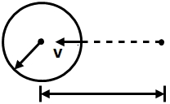

Or

Or

1. The whole space can be divided into three regions

Here, is the density of material of the sphere.

1. For

For

Slope of graph

For

,

Slope of graph

At the boundary of outer shell slope of graph

Changes from i.e., slope increases.

i.e., slope,

But

()

Constant.

1. At height distance from center of earth

Let v be the velocity at the point. Then from conservation of mechanical energy,

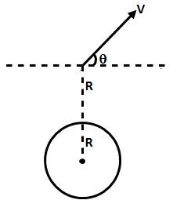

Or

Or

Let be the angle of its velocity with horizontal, then from conservation of angular momentum about center of earth.

We have

Or

Or

1. and graphs for a spherical shell and a solid sphere are as follows:

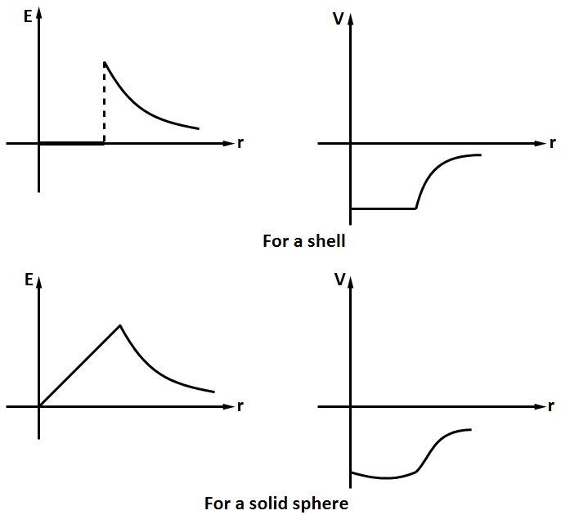

1. 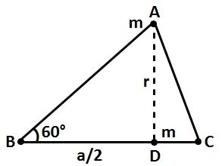Path depends on the actual magnitude of velocity and the angle at which particle is projected.

Net force on mass at is zero due to two masses at and. Only force is due to mass at







1. 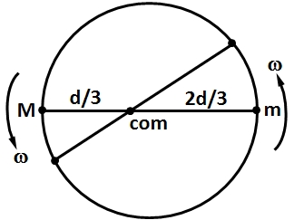For m



1. Inside a shell, constant

And

Outside the shell,

And

As increase, increase and decreases.

1. At perigee (perihelion) position planet is nearest to sun
2. Due to rotation of earth

At pole there is no effect of rotation of earth. As

At equator will increase if decreases.

Further, will increase with decrease in

From Kepler’s third law, r should also increase.

, so with increase in r, also increases.











Or

Or

Solving we get







Or